**Blockchain Lab Experiment 8**

**Shashwat Tripathi**

**D20A Roll No: 64**

**Aim:** To develop a web application that leverages blockchain technology through DApp development using Truffle

**Code:**

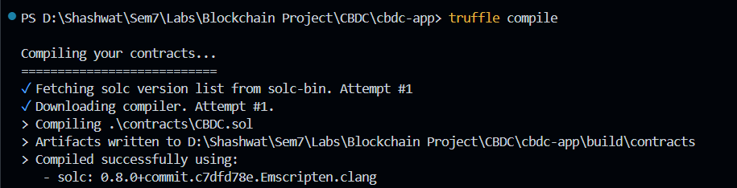

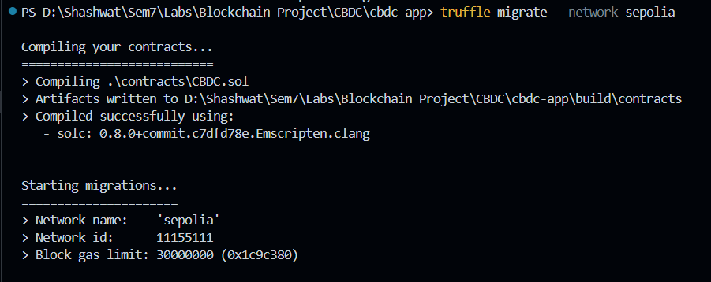

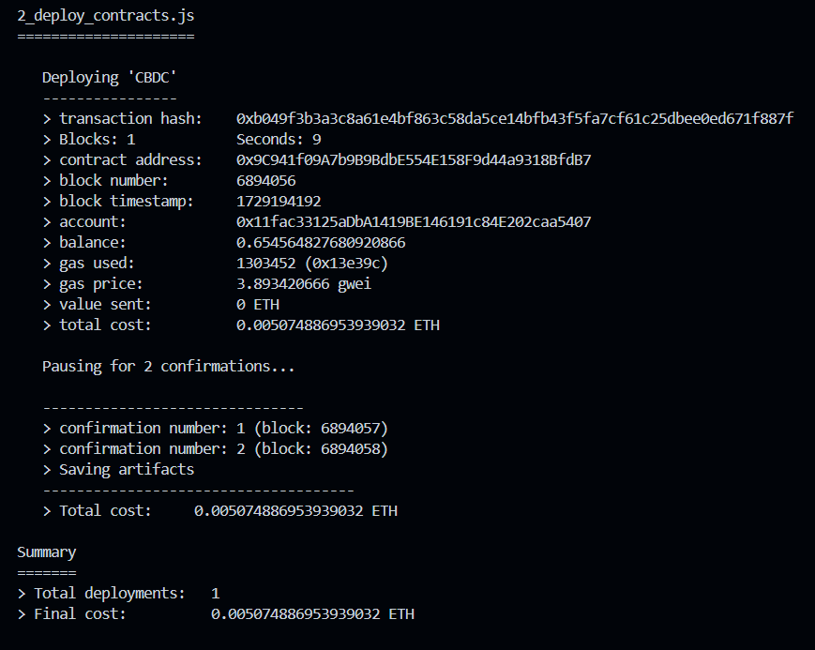

The deployment of the contract can be checked on Etherscan explorer.

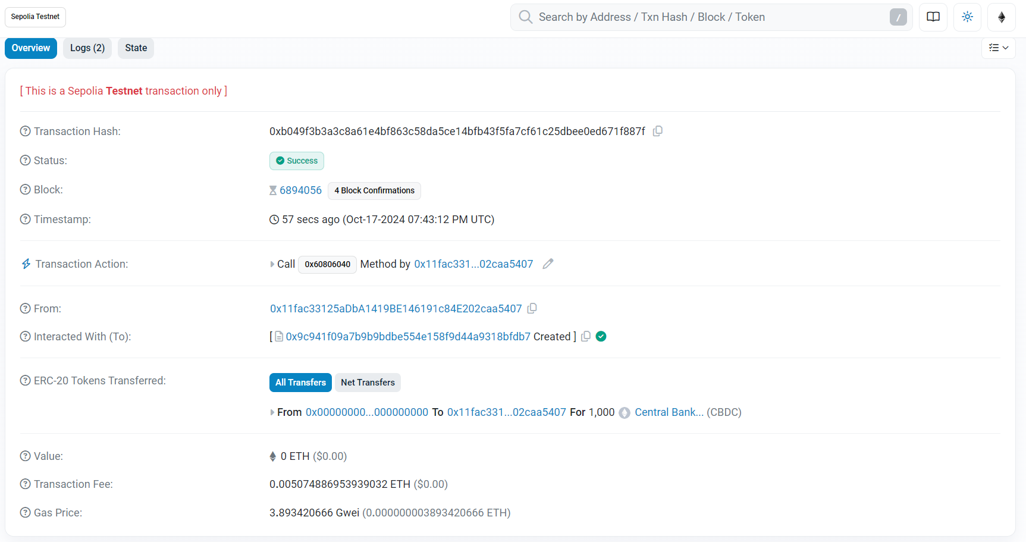

We have also written tests for our contract.

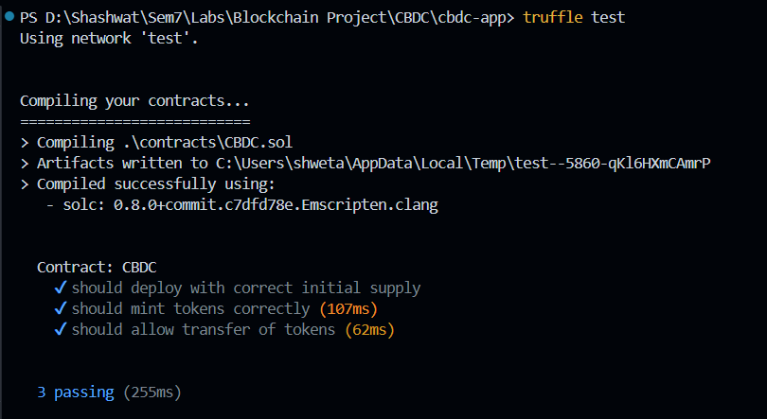

**Conclusion:** Thus, we have successfully tested, compiled and deployed the smart contract using truffle.